Lost Dogs
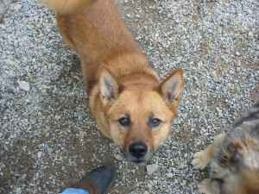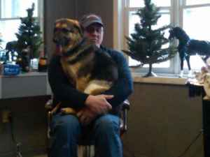

Missing since February 10, 2011 from
Sunnyside Rd in Dudley MA
IF SEEN CALL MATT at 508-868-8624 or
JESSIE at 508-868-6224

PLEASE DO NOT CHASE OR ATTEMPT TO CATCH
CALL OWNER IMMEDIATELY

LEXI is a RED Shiba Inu cross - Looks fox like with a tail that
curls over her back
LUCY is a small BLACK & TAN German Shepherd
Both Dogs are Wearing Collars and One May Be Dragging a Leash

(508) 868-8624 or (508) 868-6224

